**Project Title: Optimizing User, Group, and Role Management with Acces Control and Workflows**

**Team ID: NM2025TMID12818**

**Team Leader: S.Ganesh Kumar**

**Team Member 1: P.Roshan**

**Team Member 2: S.Gokul**

**Team Member 3: S.Harini**

**Problem Statement:**

**In a small project management team, there are two main roles: Alice, the Project Manager, and Bob, the Team Member. The challenge lies in managing project tasks efficiently while ensuring clear accountability throughout the project lifecycle.**

**The existing setup has some gaps:**

* **There are no well-defined roles for team members.**
* **Access control is missing, meaning users can see or edit data they shouldn’t.**
* **There is no proper workflow, which creates confusion in assigning tasks and tracking progress.**

**Because of these issues, tasks often become unclear, updates are inconsistent, and it is difficult to monitor who is responsible for what. This leads to delays, miscommunication, and overall inefficiency in completing projects.**

**Milestone:1**

**Create Users**

Adding a new user in ServiceNow is just like creating an account on any online platform. The process is simple and ensures that every person has their own login identity.

**Steps to create a user:**

1. Open the **ServiceNow application**.
2. From the left menu, go to **All** and search for **Users**.
3. Under the **System Security** section, click on **Users**.
4. Click on the **New** button to add a new user.
5. Fill in the required details such as first name, last name, email ID, and login credentials.
6. Finally, click on **Submit** to save the user profile.
7. Create one more user like this and click on submit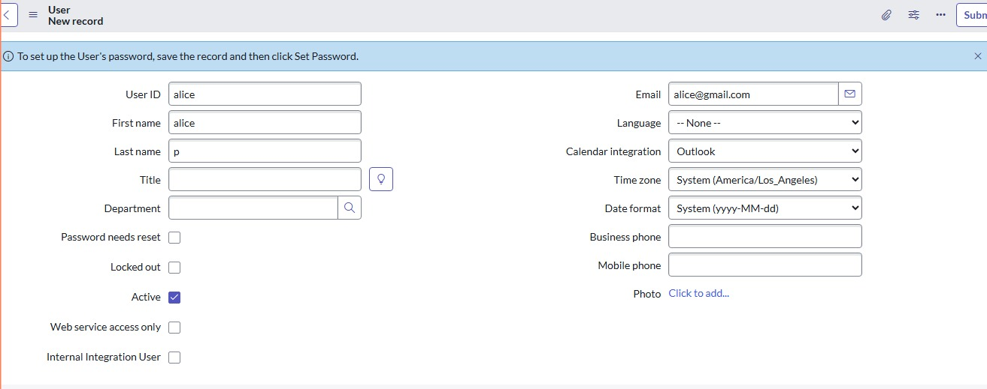

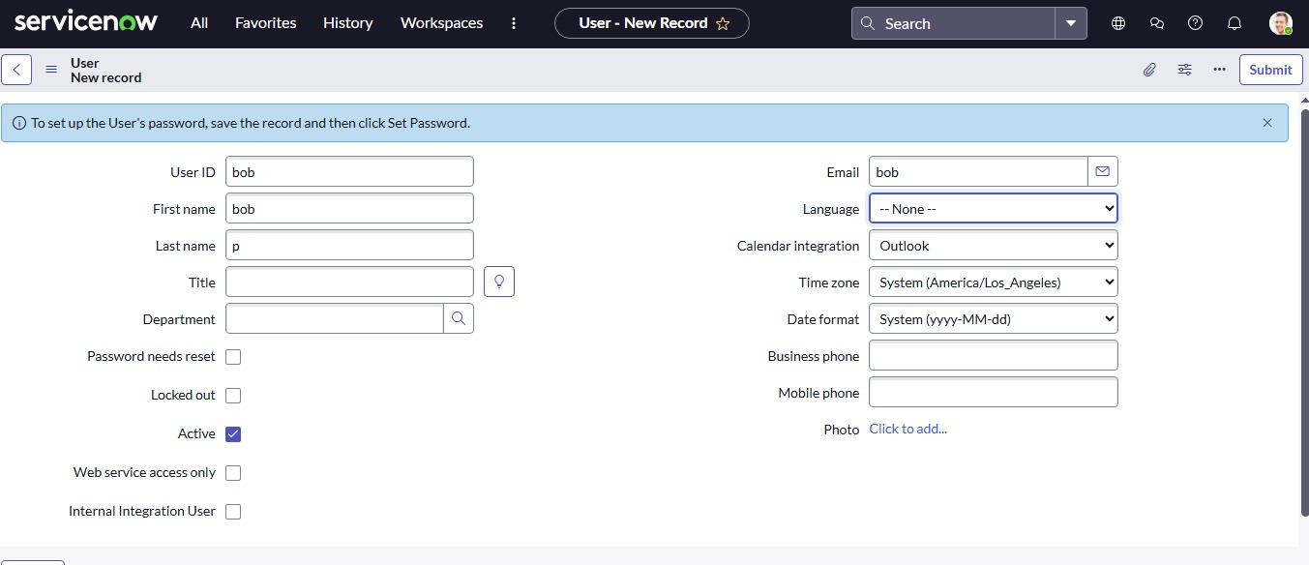

**Milestone:2**

**Create Groups**

**Group in servicenow are used to organize users together so that permissions, assignments, and workflows can be managed easily. Instead of assigning access to each user one by one, we place them into groups. For example, an “IT Support” group can handle incident tickets, while an “HR Team” group may manage employee records.**

**Steps to create a new group:**

1. **Open the servicenow application.**
2. **From the left menu, go to All and search for Groups.**
3. **Under System Security, select Groups.**
4. **Click on the New button to create a new group.**
5. **Enter the group details, such as group name (e.g., *IT Support Team*), description, and manager.**
6. **Click on Submit to save the group.**

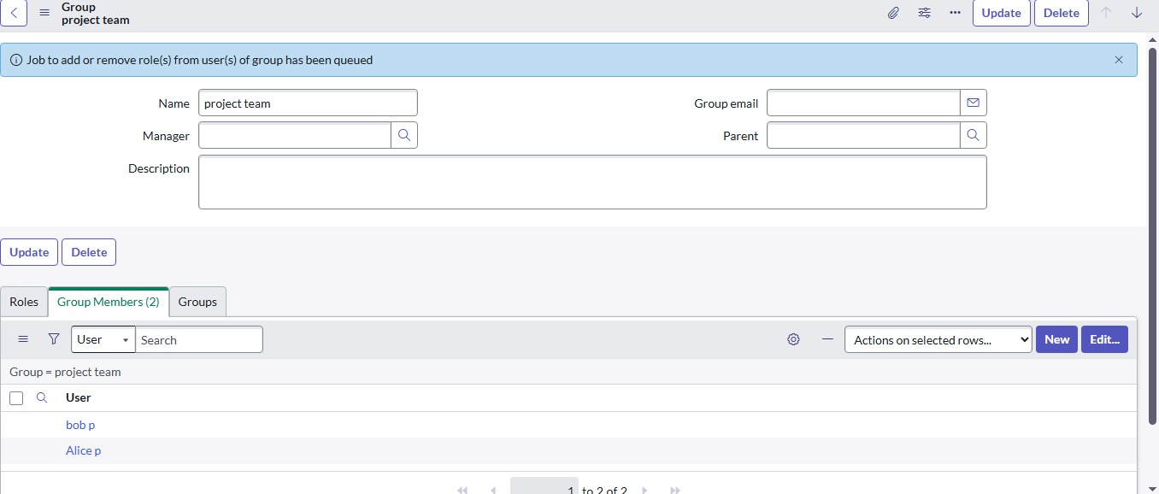

**Milestone:3**

**Create Roles**

Roles in ServiceNow define what permissions a user has. Instead of giving every user individual access, we assign roles that control what actions they can perform. For example, an **admin role** allows managing the system, while a **member role** may only allow viewing records.

**Steps to create a new role:**

1. Open the **ServiceNow application**.
2. From the left menu, go to **All** and search for **Roles**.
3. Under **System Security**, select **Roles**.
4. Click on the **New** button to create a new role.
5. Enter the role details, such as role name (e.g., “Project Member”) and description.
6. Click on **Submit** to save the role.

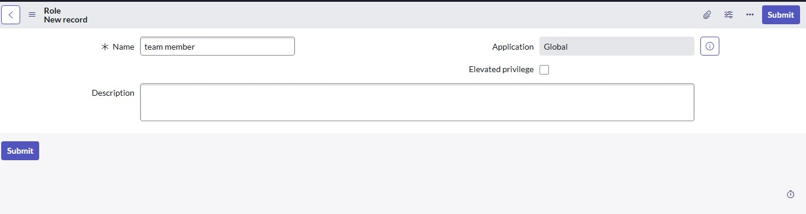

**Milestone :4**

**Create Table**

In ServiceNow, tables are used to store data. Each table contains rows and columns, just like an Excel sheet. Creating a new table allows us to organize and manage different types of information.

**Steps to create a new table:**

1. Open the **ServiceNow application**.
2. From the left-hand menu, go to **All** and search for **Tables**.
3. Under **System Definition**, click on **Tables**.
4. Click on the **New** button to create a table.
5. Fill in the details:
   * **Label:** Project Table
   * Check the boxes **Create Module** and **Create Mobile Module**
   * In the **New Menu Name**, type **Project Table**
   * Add the required **columns** with appropriate names and data types
6. After completing the details, click on **Submit** to save the table.

You can also create additional tables when needed. For example:

* Create another table called **Task Table 2**.
* Fill in the necessary details and add columns.
* Finally, click **Submit** to save.

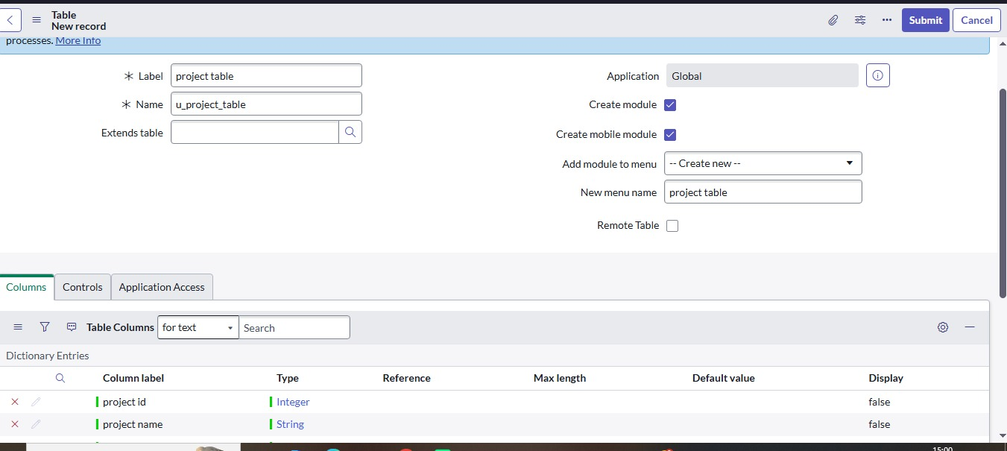

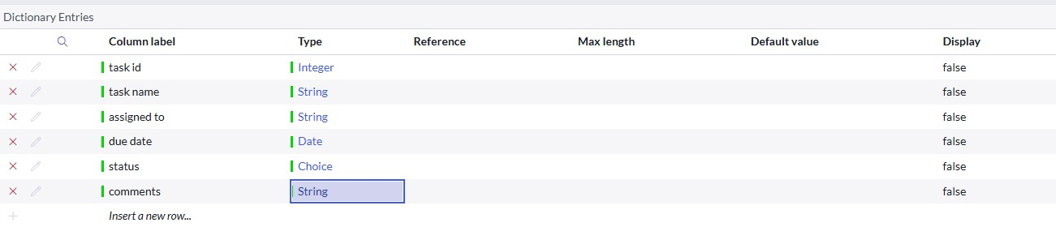

**Milestone :5**

**Assign Users to Project Team Group**

Groups in ServiceNow help manage multiple users together. Instead of assigning roles and permissions one by one, we can simply add users into a group. Once added, they automatically get the access that the group has.

**Steps to assign users to a group:**

1. Open the **ServiceNow application**.
2. From the left menu, go to **All** and search for **Groups**.
3. Under **System Definition**, select **Groups**.
4. Find and select the group named **Project Team Group**.
5. Go to the **Group Members** tab.
6. Click on **Edit** to add members.
7. From the list, select users such as **Alice P** and **Bob P**, then save the changes.

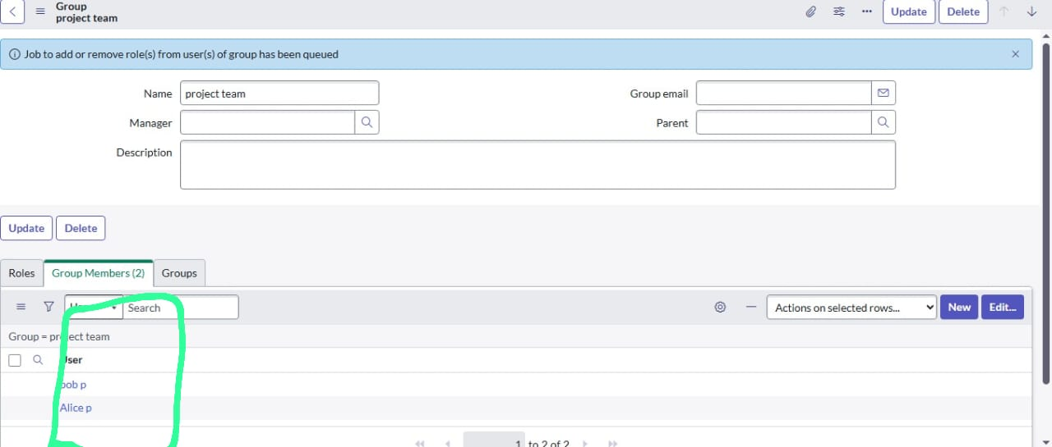

**Milestone :6**

**Assign roles to users**

**Assign Roles to Alice User**

Roles in ServiceNow decide what a user can and cannot do. Assigning the right role ensures that the user has access only to the functions they need.

**Steps to assign roles:**

1. Open the **ServiceNow application**.
2. From the left-hand menu, go to **All** and search for **Users**.
3. Under **System Definition**, select **Users**.
4. From the list, choose the user **Alice (Project Manager)**.
5. Scroll down to the **Roles** section.
6. Click on **Edit** and add the role **Project Member**, then save.
7. Again, click on **Edit** and assign additional roles such as **u_project_table** and **u_task_table**.
8. Save and update the form to confirm the changes.

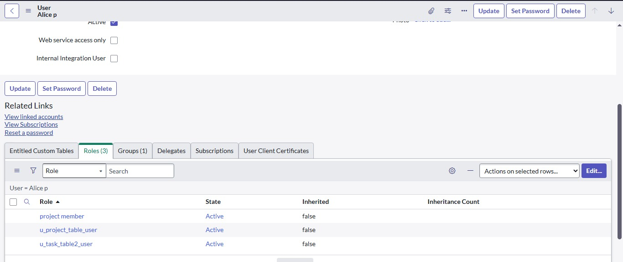

**Assign Roles to Bob User**

Just like Alice, Bob also needs specific roles in ServiceNow so that he can access the correct modules and perform his tasks. By assigning roles, we ensure that Bob gets the permissions he needs without giving unnecessary access.

**Steps to assign roles:**

1. Open the **ServiceNow application**.
2. From the left menu, go to **All** and search for **Users**.
3. Under **System Definition**, select **Users**.
4. From the list, choose the user **Bob P (Team Member)**.
5. Scroll down to the **Roles** section.
6. Click on **Edit**, select the **Team Member** role, and also assign the appropriate **table role**, then save.
7. To test, click on the **Profile Icon** and choose **Impersonate User → Bob**.
8. Now, when logged in as Bob, you will be able to see the **Task Table 2** assigned to him.

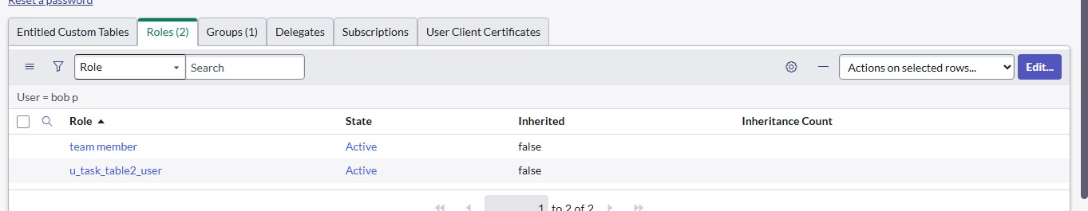

**Milestone :7**

**Application access:**

**Assign Table Access to Application**

Whenever we create a new table in ServiceNow, the system automatically generates an application and a module for it. To make sure only the right people can access these applications, we need to assign roles.

**Steps to assign access:**

1. Open the **Application Navigator** and search for the **Project Table application**.
2. Click on **Edit Module** for this application.
3. Assign the **Project Member** role to this application so only project members can access it.
4. Next, search for the **Task Table 2 application**.
5. Click on **Edit Application**.
6. Assign both the **Project Member** role and the **Team Member** role for this application.

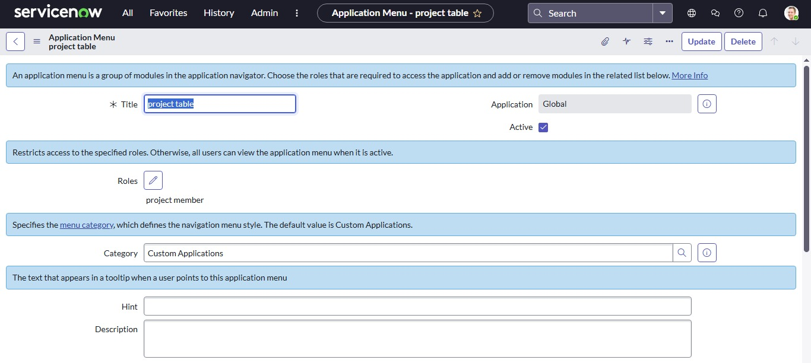

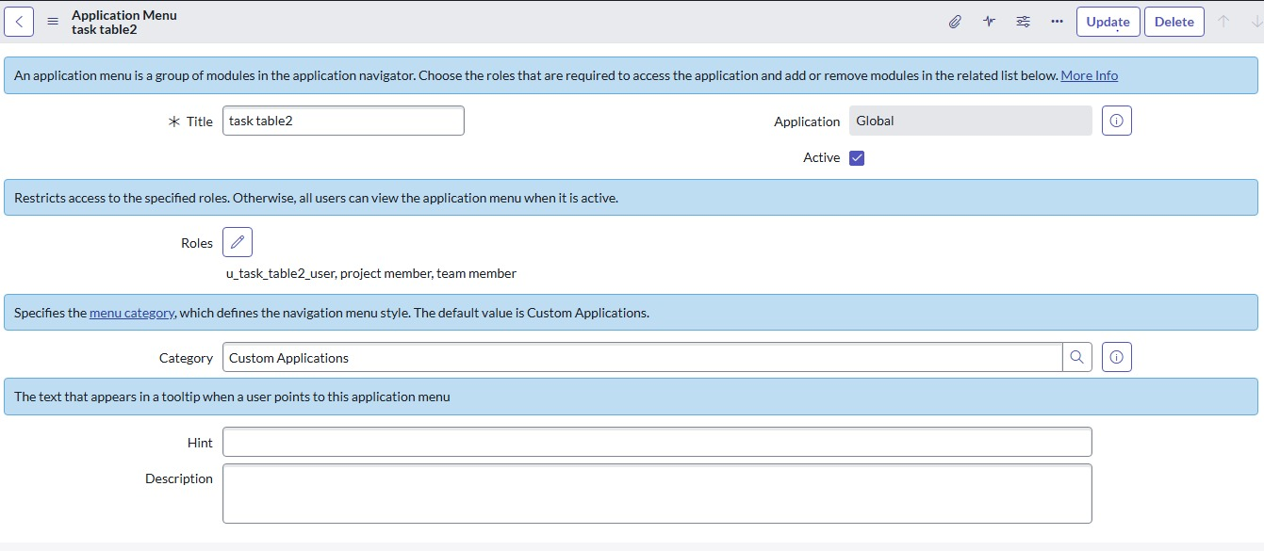

**Milestone :8**

**Create ACL**

Access Control Lists (ACLs) in ServiceNow are like security rules. They decide who can view, edit, or update certain data in tables. Without ACLs, users might see or change information they shouldn’t, so it’s an important step in access management.

**Steps to create an ACL:**

1. Open the **ServiceNow application**.
2. From the left menu, go to **All** and search for **ACL**.
3. Under **System Security**, click on **Access Control (ACL)**.
4. First, click on **Elevate Role** to gain the required permissions.
5. Then, click on **New** to create a new ACL.
6. Fill in the details for the ACL.
7. Scroll down to the **Requires Role** section.
8. Double-click to insert a new row, and assign it to the **Task Table** and the **Team Member** role.
9. Finally, click on **Submit** to save the ACL.

Similarly, you can create **4 ACLs** for specific fields (like comment and status) to define exactly which roles can edit them.

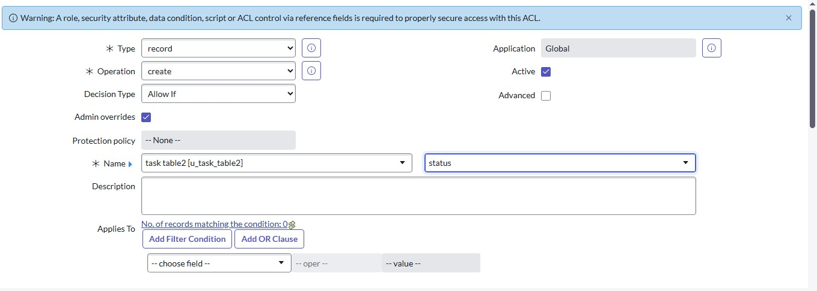

**Testing the ACL:**

1. Click on your profile at the top right corner.
2. Choose **Impersonate User**.
3. Select **Bob** as the user.
4. From the menu, go to **All → Task Table 2**.
5. You will see that Bob now has **edit access** to the **Comment** and **Status** fields.

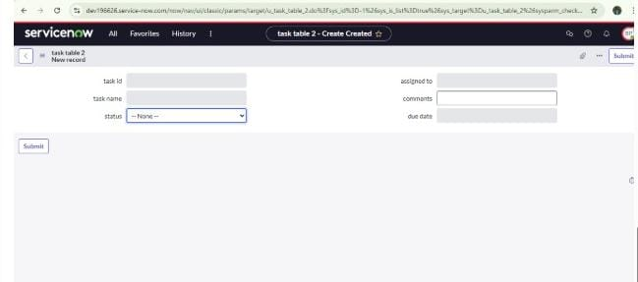

**Milestone :9**

**Flow**

**Create a Flow to Assign Operations Ticket to Group**

Flows in ServiceNow help automate processes so tasks happen automatically without manual effort. Using **Flow Designer**, we can create a flow that assigns and updates tickets based on conditions.

**Steps to create the flow:**

1. Open the **ServiceNow application**.
2. From the left menu, go to **All** and search for **Flow Designer**.
3. Under **Process Automation**, click on **Flow Designer**.
4. Click on **New → Flow**.
5. In the **Flow Properties** section:
   * Give the Flow Name: **Task Table**
   * Select Application: **Global**
6. Click on **Build Flow** to start designing.

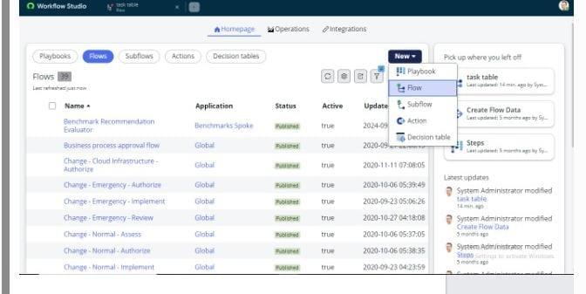

**Step 1: Add a Trigger**

1. Click on **Add a Trigger**.
2. Search for **Create Record** and select it.
3. Set the table name as **Task Table**.
4. Add conditions:
   * **Status** is **In Progress**
   * **Comments** is **Feedback**
   * **Assigned To** is **Bob**
5. Click **Done**.

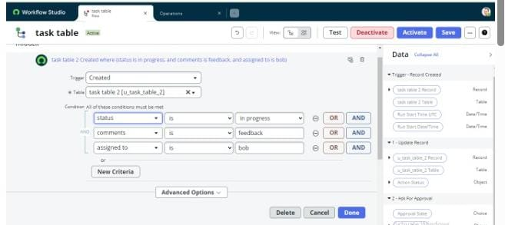

**Step 2: Add an Action – Update Records**

1. Click on **Add an Action**.
2. Search for **Update Records** and select it.
3. In the record field, drag the fields from the **Data Navigation (Right side)**.
4. The table will be auto-assigned.
5. Add the field **Status** and set the value as **Completed**.
6. Click **Done**.

**Step 3: Add an Action – Ask for Approval**

1. Again, click on **Add an Action**.
2. Search for **Ask for Approval** and select it.
3. In the record field, drag the fields from the **Data Navigation (Right side)**.
4. The table will be auto-assigned.
5. Set the approval field as **Status**.
6. Set the **Approver** as **Alice P**.
7. Click **Done**.

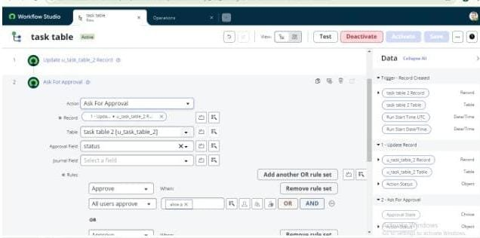

**Testing the Flow**

1. In the Application Navigator, search for **Task Table**.
2. Check the **Status** field – it should now update to **Completed** automatically.
3. Then, search for **My Approvals**.
4. Click on **My Approvals** under the **Service Desk**.
5. Alice P will see an approval request.
6. Right-click on the request and select **Approved**.

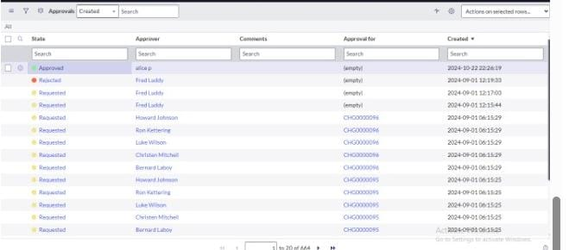

**Conclusion**

This scenario highlights how ServiceNow can be used for **structured project management**. By assigning the right roles and responsibilities, the system ensures smooth teamwork and clear accountability.

In this project:

* **Alice** acted as the project manager, handling approvals and monitoring progress.
* **Bob** carried out the assigned tasks, updating the system as work progressed.
* **Tables** like *Project Table* and *Task Table 2* helped organize information, making it easier to track projects, tasks, and updates.
* **Workflows** automated repetitive steps, ensuring consistency and saving time.

Overall, this system improved **collaboration, communication, and efficiency**. With proper user roles, group management, ACLs, and workflows, organizations can manage projects effectively while reducing errors and maintaining security.